ALTERNATING CURRENT

CHAPTER IMPORTANCE AND WEIGHTAGE
The chapter Alternating Current is highly conceptual and carries significant weightage in both Board exams and JEE. It is characterized as a calculative segment where students can score easily if they grasp the fundamental segments. Preparation for Boards during this period also helps revise JEE Main formulas and derivations.

DEFINITION OF DIRECT CURRENT (DC)
Direct Current is defined as current where the magnitude and direction remain constant over time.
- Example: Current from a battery usually remains at a steady value like 2A or 10A.
- Direction: The current flows in a single direction throughout its duration.

DEFINITION OF ALTERNATING CURRENT (AC)
Alternating Current is defined as current where both the magnitude and the direction vary with time.
- Magnitude: The value of the current changes at every instant.
- Direction: The current flows in one direction (positive) for a specific time and then reverses (negative) for another interval.
- Periodic Nature: For a current to be considered AC, “it should ideally be a periodic function with regular intervals” of positive and negative values.

AC WAVEFORMS
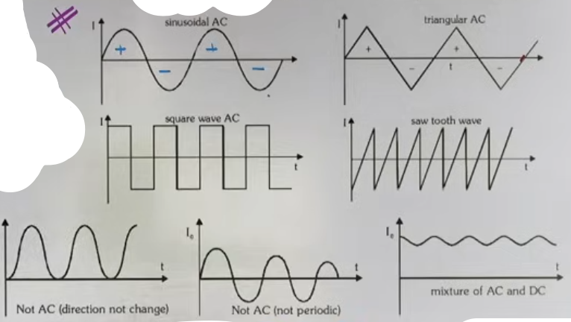
While the syllabus focuses primarily on sinusoidal AC, several types of waveforms exist:
- Sinusoidal AC: The most common form, following a sine or cosine curve.
- Triangular AC: The magnitude varies linearly, forming a triangular shape.
- Pulse or Square Wave: The current stays at a constant positive value for a duration and then jumps to a constant negative value.
- Sawtooth Wave: Named for its resemblance to the teeth of a saw, where the signal rises and then drops sharply.

MIXTURE OF AC AND DC
A circuit can carry a current that is a combination of both AC and DC components.
- Mathematical Representation: I = A + B sin(ωt).
- Here, "A" represents the constant DC component, and "B sin(ωt)" represents the alternating AC component.
- Graphical Shift: In a pure AC wave (I = I₀ sin(ωt)), the graph oscillates around the zero axis. Adding a DC component (A) shifts the entire graph vertically by "A" units.
- Result: The current may no longer cross the zero axis if the DC component is large enough, but it still contains an alternating component.

FORMULA SHEET
+----------+--------------------------+------------------------------------+
| VARIABLE | DEFINITION | NOTES |
+----------+--------------------------+------------------------------------+
| I_dc | Direct Current | Constant magnitude/direction |
| I_ac | Alternating Current | Varying magnitude/direction |
| I(t) | Instantaneous Current | Value at a specific time t |
| I₀ | Peak Current (Amplitude) | Maximum value of AC |
| ω | Angular Frequency | Determines the rate of oscillation |
+----------+--------------------------+------------------------------------+

KEY EQUATIONS:
- Standard Sinusoidal AC: I = I₀ sin(ωt)
- Mixed Signal: I = I_dc + I₀ sin(ωt)
- Condition for AC: Direction must change (cross the zero axis) periodically.

CONCEPT CONNECTIONS

MATHEMATICAL LINK
The shifting of AC graphs using DC components is a direct application of function shifting in Mathematics (e.g., y = f(x) + c).

SEMICONDUCTOR LINK
The concepts of waveforms like pulse waves or half-cycles are often encountered in semiconductor studies, such as in clipping or rectification (Half-wave and Full-wave rectifiers).

EXAMPLES AND APPLICATIONS
ANALYZING I = 2 + sin(ωt)
- Components: This current has a DC value of 2 and an AC component with a peak of 1.
- Analysis: A pure sine wave goes from +1 to -1.
- Shift: Adding 2 shifts the range. The new range is (2+1) to (2-1), which is 3 to 1.
- Conclusion: Because the current values stay between 1 and 3, it never becomes negative. It is a mixture of AC and DC but oscillates entirely in the positive region.

COMMON MISTAKES AND TRAPS
MISTAKE | WHY STUDENTS MAKE IT | CORRECT APPROACH / THINKING
Pulsating DC as AC | It varies in magnitude, so students call it AC. | Magnitude change is not enough; direction (sign) must change for pure AC.
Shift Errors | Shifting the peak instead of the axis | The entire waveform (including the mean position) shifts by the DC value.
Ignoring Periodicity | Thinking any variable current is AC | AC must be periodic and change direction at regular intervals.

HIGH-YIELD REVISION SHEET
MUST REMEMBER:
- DC = Constant Magnitude + Constant Direction.
- AC = Variable Magnitude + Variable Direction.
- Pure AC oscillations happen around the zero axis.
- Mixed signals shift the oscillation axis away from zero.

LAST-MINUTE REVISION POINTS:
- I = I₀ sin(ωt) is the standard equation.
- Waveform types: Sinusoidal, Triangular, Square/Pulse, Sawtooth.
- In a mixed signal I = A + B sin(ωt), the AC amplitude is B, not A+B.
- Pure sinusoidal AC has an average value of zero over a full cycle.

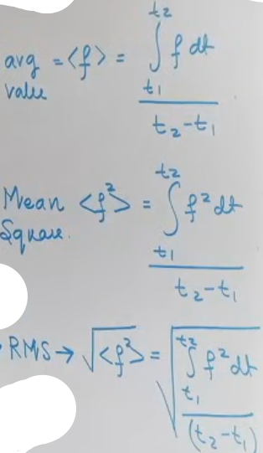
THE NEED FOR REPORTING VALUES
In Alternating Current (AC), the magnitude and direction vary at every instant (e.g., I = I₀ sin ωt).
Because the value is constantly changing, it is impossible to report a single "instantaneous" value to describe the current effectively for practical use.
To solve this, we use two primary statistical reporting methods:
1. Average Value: Focuses on the total charge transferred by the current.
2. Root Mean Square (RMS) Value: Focuses on the work done or heat produced by the current.

AVERAGE CURRENT (I_avg)
Definition: The steady DC current which would transfer the same total charge through a circuit in a given time interval as is transferred by the actual time-varying AC current.
# avg I = total Q / total time
Formula: I_avg = (ₜ₁∫ᵗ² I dt) / (t₂ – t₁)

Physical Significance: Since the area under an I-t graph represents charge (Q = Integral of I dt), the average current is the value that produces the same area under the graph for that time interval.

SPECIFIC CALCULATIONS FOR SINUSOIDAL WAVES
1. Full Cycle (0 to T): The average value is ZERO. This is because the positive area of the first half-cycle exactly cancels the negative area of the second half-cycle.
2. Half Cycle (0 to T/2):
Formula: I_avg = 2I₀ / π.
Numerical Value: approximately 0.637 * I₀.
Calculation Logic: Integrate I₀ sin ωt from 0 to T/2 and divide by T/2.
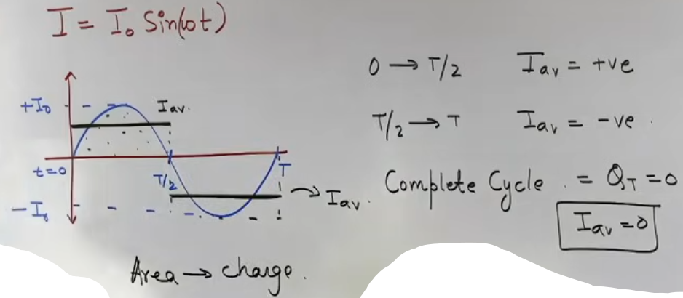
ROOT MEAN SQUARE (RMS) CURRENT (I_rms)
Definition: Also known as the "Effective Current" or "Virtual Current".
It is the steady DC current which would produce the same amount of heat in a given resistor in a given time as is produced by the time-varying AC current in the same resistor during the same time.

Mathematical Steps (RMS = Root-Mean-Square):
1. SQUARE: Square the current function I(t)².
2. MEAN : Find the average (mean) of that squared function over a cycle.
3. ROOT : Take the square root of that mean value.

Mathematical Formula: I_rms = √[ (Integral of I² dt) / (Time Interval) ].
Standard Sinusoidal Result: I_rms = I₀ / √2 ≈ 0.707 * I₀.

Heat (by DC) = (I²_DC)(R)(t₂ - t₁) ; Heat (by AC) = ₜ₁∫ᵗ² (I²_AC)(R)dt
from definition :
(I²_DC)(R)(t₂ - t₁) = ₜ₁∫ᵗ² (I²_AC)(R)dt
I²_DC = [ₜ₁∫ᵗ² (I²_AC)dt]/(t₂ - t₁) # R cancels
“ I_DC = √[ₜ₁∫ᵗ²(I²_AC)dt/(t₂ – t₁)] “
# which in fact is equal to the root mean square value of the ac current therefore RMS is the effective value of ac current.

[ THE HEAT INDEPENDENCE OF DIRECTION
The reason RMS is more useful than Average for full cycles is that heat dissipation (H = I²Rt) depends on the square of the current. Since the square of a negative number is positive, the "negative" half of the AC cycle still produces positive heat. This is why your home appliances work even though the average current over a full cycle is zero. ]

FORMULA SHEET
+-------------------+---------------------------+-----------------------------+
| QUANTITY | FORMULA / VALUE | NOTES |
+-------------------+---------------------------+-----------------------------+
| Average (General) | [Integral I dt]/[Delta t] | Mathematical definition |
| I_avg (Half Cycle)| 2I₀ / π (or 0.637I₀) | For sinusoidal wave |
| I_avg (Full Cycle)| 0 | For sinusoidal wave |
| I_rms (Effective) | I₀ / √2 (or 0.707I₀) | Standard sinusoidal AC |
| Heat Produced | H = (I_rms)² * R * t | Based on RMS definition |
| Charge Transferred| Q = I_avg * Delta t | Based on Average definition |
+-------------------+---------------------------+-----------------------------+
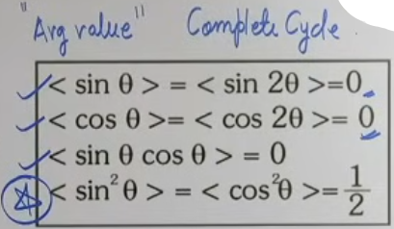

AVERAGE VALUES OF TRIGONOMETRIC FUNCTIONS OVER FULL CYCLE

CONCEPT CONNECTIONS

LINK TO INSTRUMENTATION
Most AC ammeters and voltmeters in laboratories are designed to measure and report RMS values, not peak or average values. If a device says "220V AC," it is referring to the RMS voltage.

LINK TO STATISTICS
RMS is a standard statistical tool used whenever a data set has both positive and negative values that would otherwise cancel out if simply averaged (similar to calculating standard deviation).

PROBLEM-SOLVING FRAMEWORK

QUESTION TYPE | IDENTIFICATION CLUES | APPROACH / STRATEGY
Find Average | Given I(t) as a function | Use the integral formula:  [Integral I dt] / [Delta t].
Find RMS | "Effective current" or "RMS" | Use Square Root of the average of the squared function.
Mixed Signal | I = A + B sin ωt | Use formula: I_rms = √[ A² + B²/2 ].
Graph-based | Triangle or Square wave | Calculate area for charge (Average) or area of I² (RMS).
EXAMPLES AND APPLICATIONS

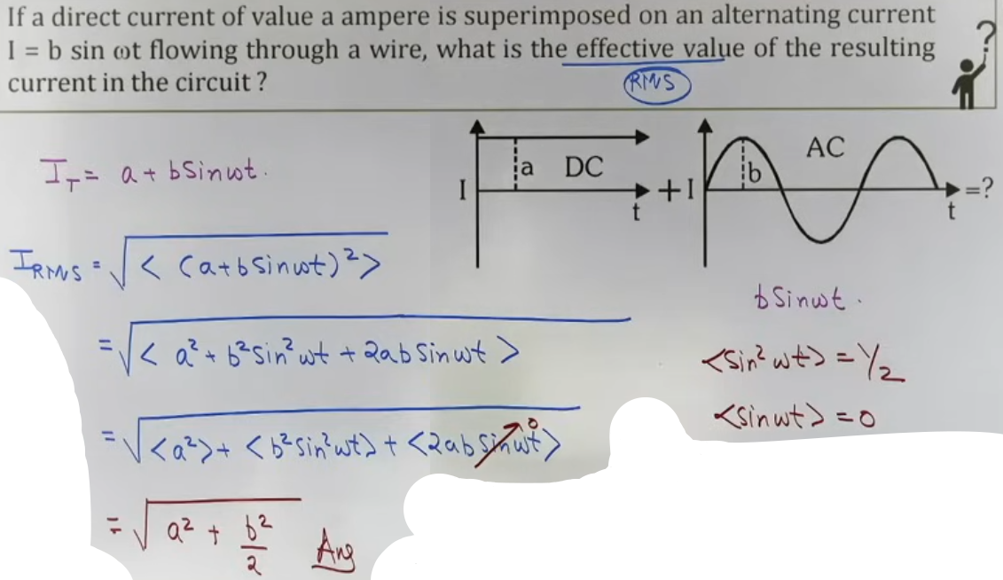

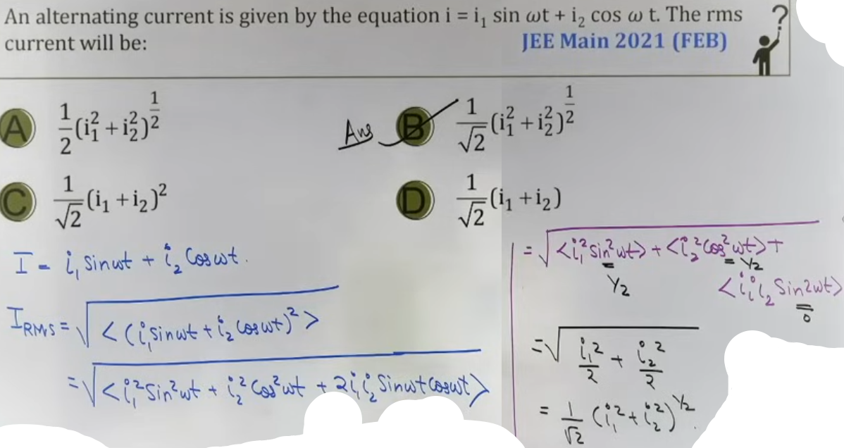

JEE ADVANCED INSIGHTS

THE ZERO AXIS SHIFT
If a DC component is added to AC (I = A + B sin ωt), the graph shifts upward. While the average over a full cycle for the "B sin ωt" part is still zero, the overall average of the signal is "A".

NON-SINUSOIDAL RMS
For a square wave that stays at +I₀ for T/2 and -I₀ for T/2, the square is always I₀². Therefore, the mean of the square is I₀², and the RMS is simply I₀.
COMMON MISTAKES AND TRAPS

MISTAKE | WHY STUDENTS MAKE IT | CORRECT APPROACH / THINKING
Full Cycle Average | Saying it's 2I₀/π | Full cycle average is ALWAYS 0 for pure sine waves.  Peak vs RMS | Confusing I₀ with I_rms | I_rms is always smaller than I₀ (I_rms = 0.707I₀).
Instrument Reading | Thinking meters show peak | AC meters always show RMS values unless specified.
Average Current | Thinking no current flows | Average current is 0, but charge DOES move; it just moves back and forth.

HIGH-YIELD REVISION SHEET

MUST REMEMBER:
- Average is for CHARGE; RMS is for HEAT.
- Average (Half Cycle) = 0.637 * Peak.
- RMS = 0.707 * Peak.
- For I = A + B sin ωt, I_rms = √[ A² + B²/2 ].
- AC meters read RMS values.

LAST-MINUTE REVISION POINTS:
- The average of sin² θ over a full cycle is 1/2.
- If you see "220V, 50Hz" on an appliance, 220V is V_rms.
- To find peak voltage from a 220V RMS supply: V₀ = 220 * √2 ≈ 311V.
- Average charge transferred in a full cycle of pure AC is zero.

--------------------------------------------------------------------------------

PHASORS AS ROTATING VECTORS
- A phasor is a vector that rotates about the origin with a constant angular velocity omega (ω). It is used to represent sinusoidal quantities like alternating current and voltage.
- The length of the phasor represents the peak value (amplitude) of the quantity (e.g., I₀ or V₀).
- The projection of this rotating vector on a vertical axis (Y-axis) at any instant gives the instantaneous value of the alternating quantity at that time.
# same as in SHM

PHASE TERMINOLOGY
Initial Phase (ϕ): This is the phase of the quantity at t = 0. It determines where the wave starts. In the equation I = I₀ sin(ωt + ϕ), ϕ is the initial phase.

Instantaneous Phase: The total angle at any time t, represented by (ωt + ϕ).
# phase decides both value and sign.

Phase Difference: The angular gap between two phasors (e.g., between voltage and current). It is calculated as Phase₁ - Phase₂.
Ex.
if Voltage V = Vₒ sin(ωt + ϕ₁)
and Current I = Iₒ sin(ωt + ϕ₂), then
Phase difference of I w.r.t. V ϕ = ϕ₂ - ϕ₁
Phase difference of V w.r.t. I ϕ = ϕ₁ - ϕ₂

Leading and Lagging:
- Leading: A wave is leading if it reaches its maximum (peak) value earlier in time than another wave. (lead: +ϕ)
- Lagging: A wave is lagging if it reaches its maximum value later in time. (lag: -ϕ)
SHIFTS in graph -
Think of the initial phase as a "head start" or a "delay".
- If you have (+ ϕ), the vector is already ahead of the start line at t = 0, so the graph is shifted to the left (negative direction).
- If you have (- ϕ), the vector starts behind the line, shifting the graph to the right (positive direction).

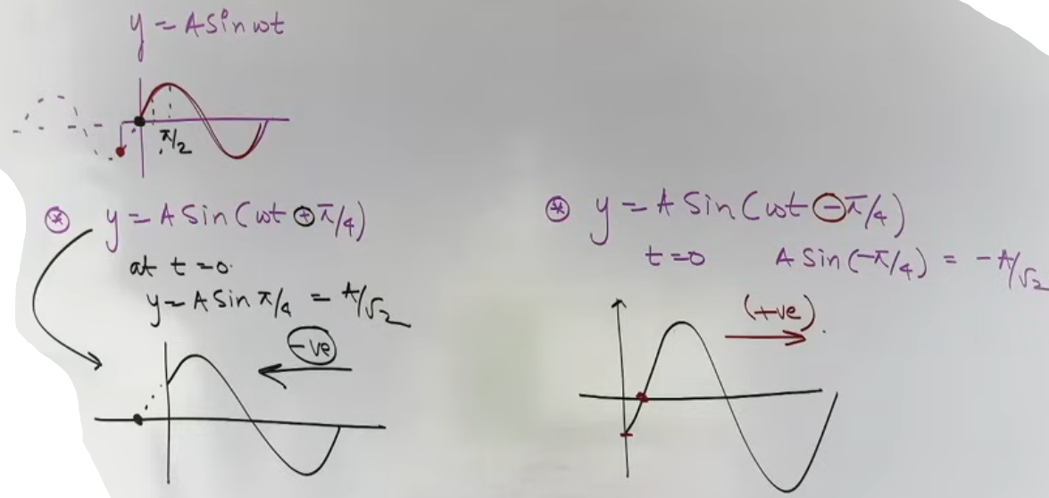
INTUITION AND CONCEPTUAL UNDERSTANDING

THE SHADOW MENTAL MODEL
Imagine a stick of length I₀ rotating in a circle. If you shine a light from the side, the shadow of the tip of the stick on a vertical wall moves up and down. This up-and-down motion is exactly what a sine wave represents. The "phasor" is the rotating stick, and the "AC current" is its shadow.

FORMULA SHEET

+-----------------------+----------------------+-------------------------------+
| QUANTITY | FORMULA | DESCRIPTION |
+-----------------------+----------------------+-------------------------------+
| Instantaneous Current | I = I₀ sin(ωt + ϕ) | Current at time t |
| Initial Phase | ϕ | Angle at t = 0 |
| Angular Frequency | ω = 2π / T | Rate of rotation |
| Phase Difference | Δϕ = (ωt+ϕ₁)-(ωt+ϕ₂) | Difference between waves |
| Projection (Y-axis) | I = I₀ sin(θ) | Instantaneous value |
| Projection (X-axis) | I = I₀ cos(θ) |Used for cosine representations|
+-----------------------+----------------------+-------------------------------+

CONCEPT CONNECTIONS

LINK TO UNIFORM CIRCULAR MOTION (UCM)
AC is essentially the mathematical projection of UCM. Every property of a rotating vector in UCM (angular speed, radius, angle) has a direct counterpart in AC (angular frequency, peak value, phase).

LINK TO VECTORS
Even though current and voltage are scalars, we treat them as vectors (phasors) in AC circuits because it simplifies the addition of multiple sinusoidal waves into a simple vector addition problem.

JEE ADVANCED INSIGHTS
THE ROTATING REFERENCE FRAME
Phasors allow us to view the entire circuit as a "frozen" snapshot in a rotating frame. By calculating the relative angles between V and I, we can solve complex RLC circuits using basic geometry instead of difficult differential equations.

NON-SINUSOIDAL PHASORS
Teacher's Note: Phasors are strictly for sinusoidal functions. You cannot use standard phasor rotation for square waves or sawtooth waves because their "shadows" do not move in simple harmonic motion.

COMMON MISTAKES AND TRAPS
MISTAKE | WHY STUDENTS MAKE IT | CORRECT APPROACH / THINKING
Sin vs Cos Confusion | Comparing sin(ωt) and cos(ωt) | Convert cos to sin using sin(ωt + π/2) before comparing phase.
Sign Error in Shift | Thinking +ϕ moves graph right | +ϕ shifts the wave LEFT (earlier start).
Assuming Peak is RMS | Forgetting the “/√2” factor | Phasor length represents the PEAK value (I₀), not RMS.
Angle with X vs Y | Confusing projection axis | Standard sin waves are Y-axis projections.

HIGH-YIELD REVISION SHEET
MUST REMEMBER:
- Phasor = Rotating Vector.
- Length = Peak Value.
- Rotation = Anticlockwise at speed ω.
- Leading = Reaches peak first.
- Lagging = Reaches peak later.
LAST-MINUTE REVISION POINTS:
- Phase difference is independent of time; the gap between phasors stays constant as they rotate.
- The "Nawab" formula from EMI (NABω sin ωt) is the physical source of the rotating phasor concept.
- In a pure resistor, the phase difference is 0.
- In a pure inductor, voltage leads current by π/2.
- In a pure capacitor, current leads voltage by π/2.
--------------------------------------------------------------------------------

PURELY RESISTIVE CIRCUIT (R)
When an alternating voltage (V = V₀ sin ωt) is applied across a pure resistor, the current and voltage remain in the same phase. This means they reach their maximum, minimum, and zero values at the exact same time.
Ohm's Law applies directly to these circuits for instantaneous, peak, and RMS values:
V = IR, V₀ = I₀R, and Vᵣₘₛ = Iᵣₘₛ(R).
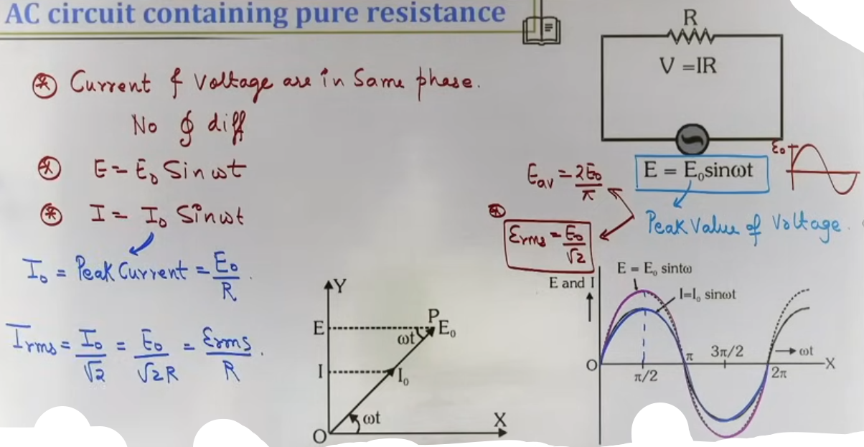
There is no phase difference (ϕ = 0) between voltage and current in a purely resistive AC circuit.

# for E = E₀ sin ωt
# E_rms = E₀/√2

PURELY INDUCTIVE CIRCUIT (L)
- An inductor is essentially a coiled wire that opposes any change in current flowing through it.
- In a purely inductive circuit, the voltage leads the current by a phase angle of 90 degrees (π/2). Alternatively, we say the current lags the voltage by π/2.
- If V = V₀ sin ωt, then I = I₀ sin(ωt - π/2).
- Inductive Reactance (Xₗ) represents the resistance-like opposition offered by the inductor to AC.
- Formula: Xₗ = ωL = 2πfL.
- Xₗ is measured in Ohms (Ω).
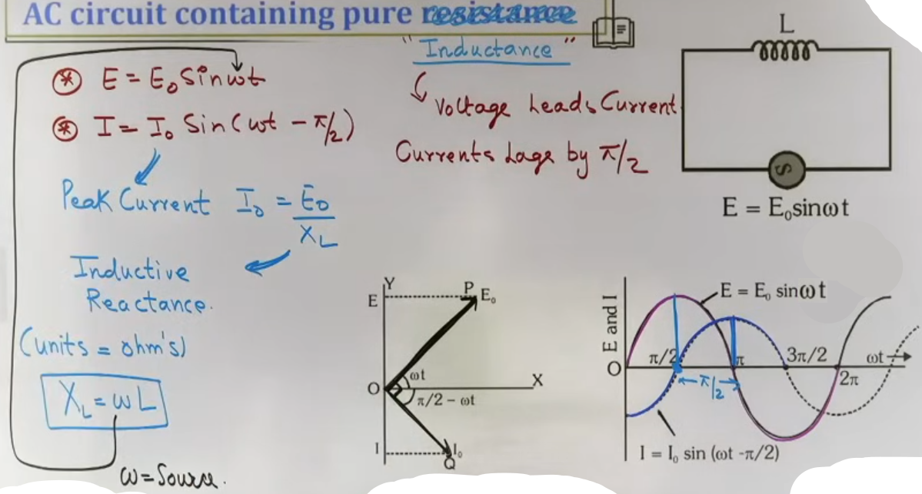
PURELY CAPACITIVE CIRCUIT (C)
- A capacitor stores energy in an electric field and opposes changes in voltage.
- In a purely capacitive circuit, the current leads the voltage by a phase angle of 90 degrees (π/2).
- If V = V₀ sin ωt, then I = I₀ sin(ωt + π/2).
- Capacitive Reactance (X꜀) is the opposition offered by the capacitor to AC.
- Formula: X꜀ = 1/(ωC) = 1/(2πfC).
- X꜀ is also measured in Ohms (Ω).
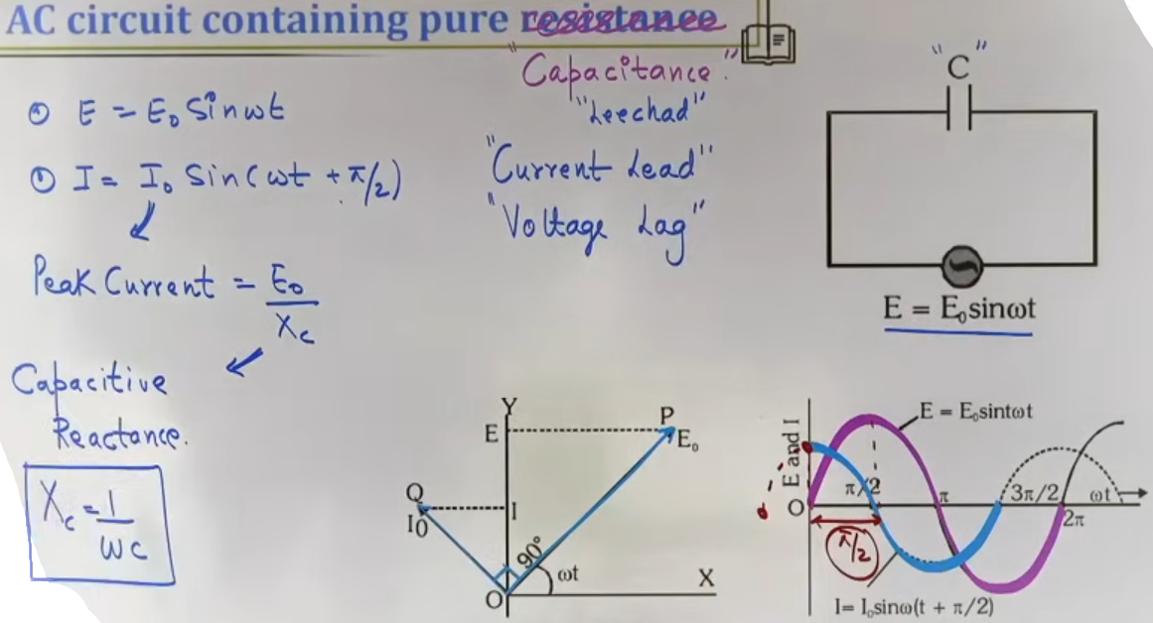
INTUITION AND CONCEPTUAL UNDERSTANDING

THE INDUCTOR AS A GHAMANDI (ARROGANT) CHILD
The teacher describes the inductor as an arrogant child who resists whatever you try to do. If you try to increase the current, it produces a back EMF to stop you; if you try to decrease it, it tries to keep it flowing. This "magnetic inertia" causes the current to lag behind the applied voltage.

THE CAPACITOR AS A DHEETH (STUBBORN/GLUTTON) CHILD
The capacitor is like a child at a wedding who eats until they are completely full and then blocks the path for everyone else. In DC, once a capacitor is fully charged, it acts as an open circuit (Infinite resistance). In AC, it allows current to flow but its "stubbornness" causes the current to lead the voltage.

FORMULA SHEET
+-----------+---------------------+--------------------+-----------------------+
| COMPONENT |OPPOSITION (REACTION)| PHASE RELATIONSHIP | FREQUENCY DEPENDENCE |
+-----------+---------------------+--------------------+-----------------------+
| Resistor | R (Resistance) | In Phase (ϕ=0) | Independent of f |
| Inductor | Xₗ = ωL | V leads I by 90⁰ | Xₗ proportional to f |
| Capacitor | X꜀ = 1/(ωC) | I leads V by 90⁰ | X꜀ proportional to 1/f|
+-----------+---------------------+--------------------+-----------------------+

PEAK CURRENT RELATIONS:
I₀ = V₀ / R (For Resistor)
I₀ = V₀ / Xₗ (For Inductor)
I₀ = V₀ / X꜀ (For Capacitor)

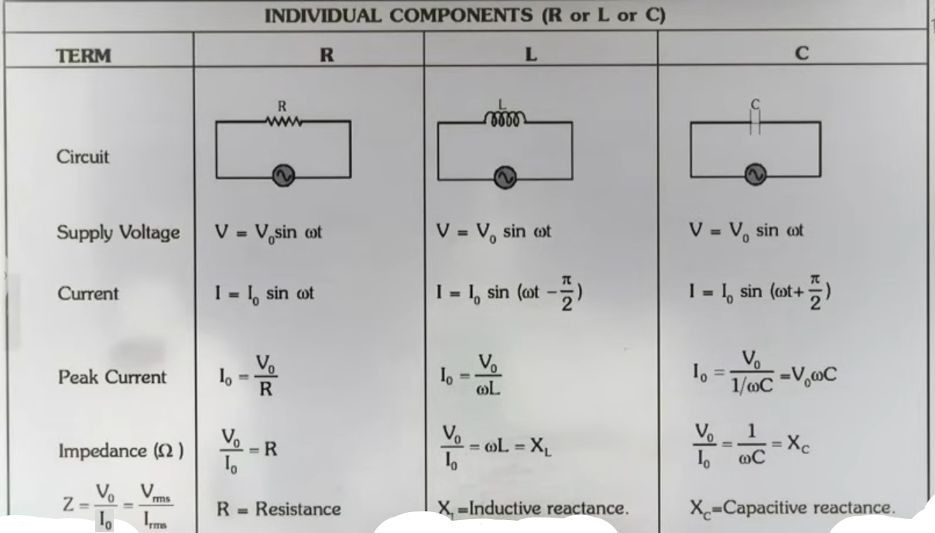
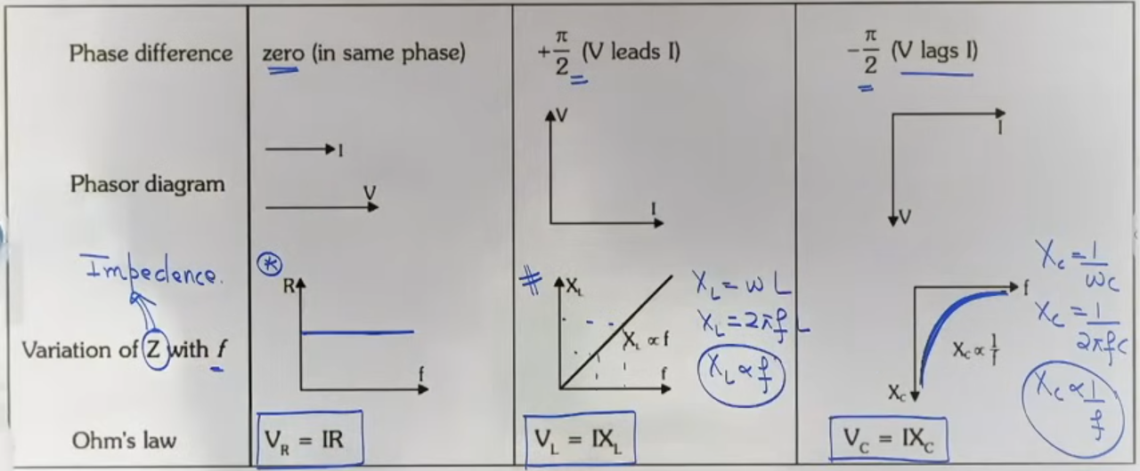

CONCEPT CONNECTIONS
DC VS AC BEHAVIOR
For DC (f = 0):
- Inductor (Xₗ = 0): Acts as a simple connecting wire (short circuit).
- Capacitor (X꜀ = infinity): Acts as a broken wire (open circuit).
For high frequency AC (f approaching infinity):
- Inductor: Acts as an open circuit (extremely high opposition).
- Capacitor: Acts as a short circuit (extremely low opposition).

EXAMPLES AND APPLICATIONS
EXAMPLE: CHANGING FREQUENCY IN INDUCTIVE CIRCUIT
If the frequency of the AC source is doubled in a purely inductive circuit:
Xₗ = 2πfL. If f is doubled, Xₗ is doubled.
Current I₀ = V₀/Xₗ. If Xₗ doubles, the current becomes half.

EXAMPLE: CHANGING FREQUENCY IN CAPACITIVE CIRCUIT
If the frequency of the AC source is doubled in a purely capacitive circuit:
X꜀ = 1/(2πfC). If f is doubled, X꜀ becomes half.
Current I₀ = V₀/X꜀. If X꜀ is halved, the current doubles.

JEE ADVANCED INSIGHTS
REAL INDUCTORS
In reality, every inductor is made of wire which has some resistance. Therefore, a real inductor is always an RL circuit, not a "pure" L circuit. The phase difference will be less than 90 degrees but greater than 0.

HIGH-YIELD REVISION SHEET

MUST REMEMBER:
- Resistor: ϕ = 0, R = constant.
- Inductor: V leads I by 90⁰, Xₗ = ωL.
- Capacitor: I leads V by 90⁰, X꜀ = 1/ωC.
- Xₗ vs f graph: Straight line through origin.
- X꜀ vs f graph: Hyperbola (inversely proportional).

PHASE SUMMARY TABLE:
_______________________________________________________
CIRCUIT TYPE | VOLTAGE EQUATION | CURRENT EQUATION
Pure R | V = V₀ sin ωt | I = I₀ sin ωt
Pure L | V = V₀ sin ωt | I = I₀ sin(ωt - π/2)
Pure C | V = V₀ sin ωt | I = I₀ sin(ωt + π/2)
_______________________________________________________
LAST-MINUTE REVISION POINTS:
- Inductive reactance (Xₗ) is zero for DC.
- Capacitive reactance (X꜀) is infinite for DC.
- Power dissipated in pure L and pure C circuits is ZERO because cos(90⁰) = 0.
- A capacitor is used to block DC while allowing AC to pass.

--------------------------------------------------------------------------------
SERIES RL AND RC CIRCUITS
In alternating current (AC) circuits involving combinations of elements, we apply Kirchhoff's Voltage Law (KVL). However, because voltages across resistors, inductors, and capacitors are not in phase, we cannot add their magnitudes algebraically. Instead, we treat them as vectors (phasors) and perform vector addition.

SERIES RL CIRCUIT
- When a resistor (R) and inductor (L) are in series, the same current (I) flows through both.
- The voltage across the resistor (Vᵣ) is in phase with the current.
- The voltage across the inductor (Vₗ) leads the current by 90 degrees.
- The net voltage (V_net) is the vector sum of Vᵣ and Vₗ, which are perpendicular to each other.
- V_net = √(Vᵣ² + Vₗ²).
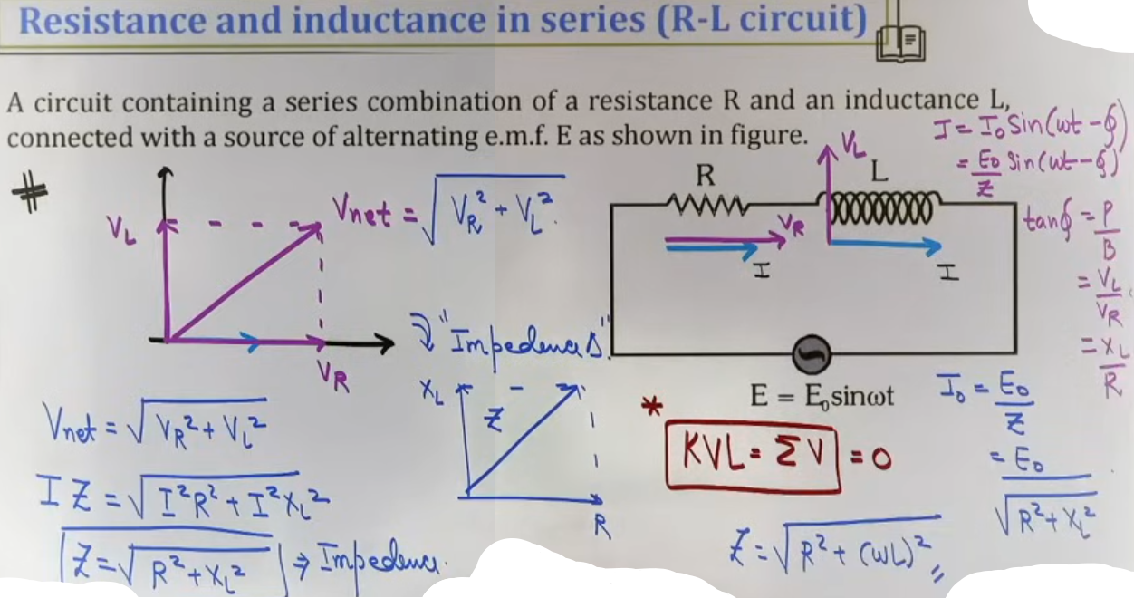
SERIES RC CIRCUIT
- When a resistor (R) and capacitor (C) are in series, the same current (I) flows through both.
- The voltage across the resistor (Vᵣ) is in phase with the current.
- The voltage across the capacitor (V꜀) lags the current by 90 degrees.
- The net voltage (V_net) is the vector sum of Vᵣ and V꜀, which are perpendicular.
- V_net = √(Vᵣ² + V꜀²).
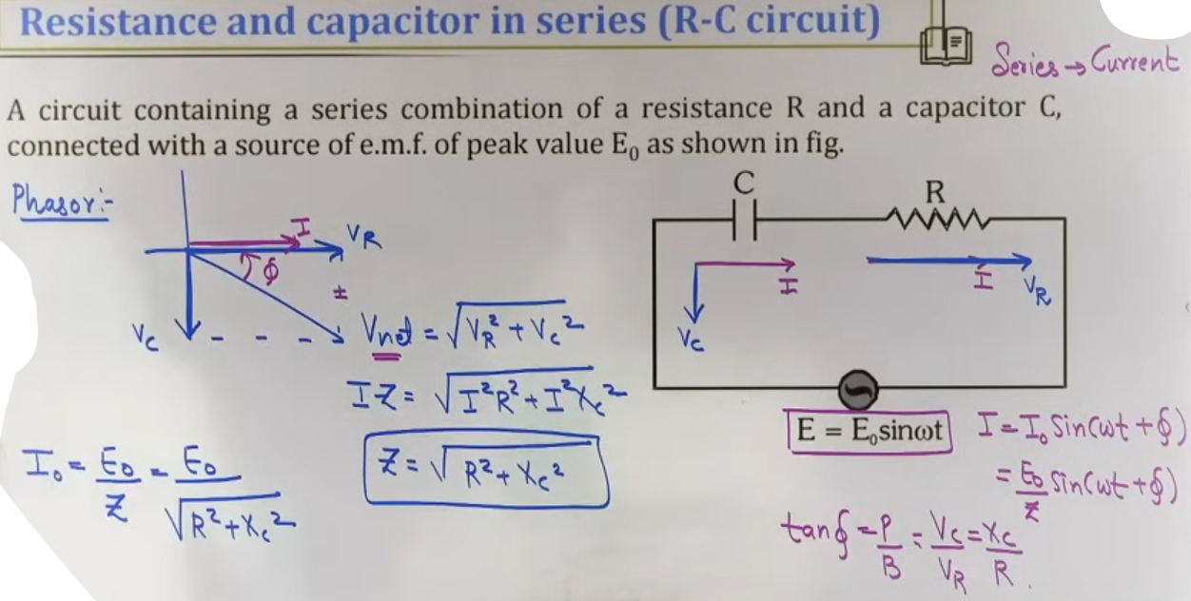
IMPEDANCE (Z)
Impedance is the total effective opposition offered by a combination circuit to the flow of AC. It is the AC equivalent of total resistance.
For RL: Z = √(R² + Xₗ²).
For RC: Z = √(R² + X꜀²).
# impedance source ke omega aur frequency p depend karega.

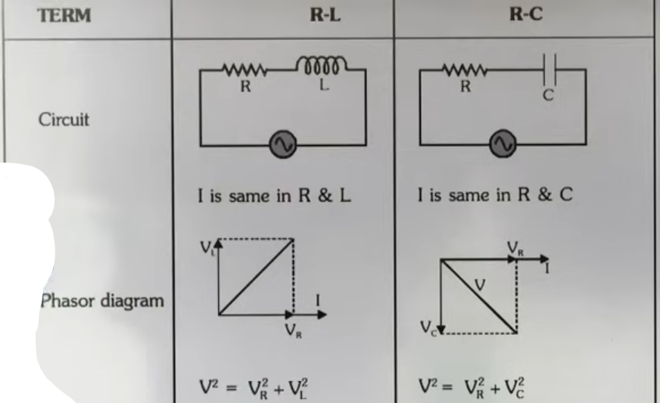

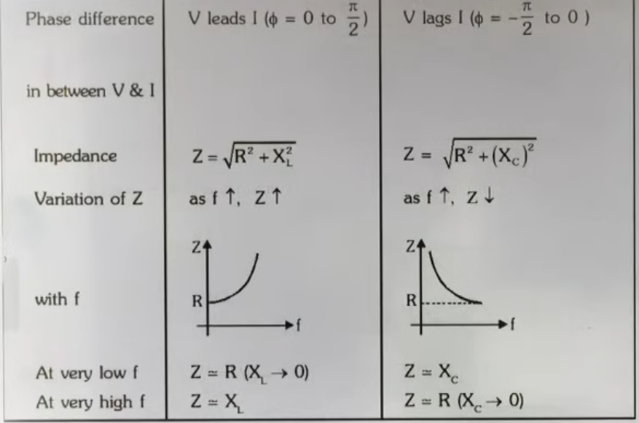
SERIES RLC CIRCUIT
- In a circuit with R, L, and C in series, current (I) is common to all.
- Vₗ and V꜀ are 180 degrees out of phase (pointing in opposite directions).
- The net reactive voltage is (Vₗ - V꜀) if Vₗ > V꜀, or (V꜀ - Vₗ) if V꜀ > Vₗ.
- The total impedance Z = √(R² + (Xₗ – X꜀)²).

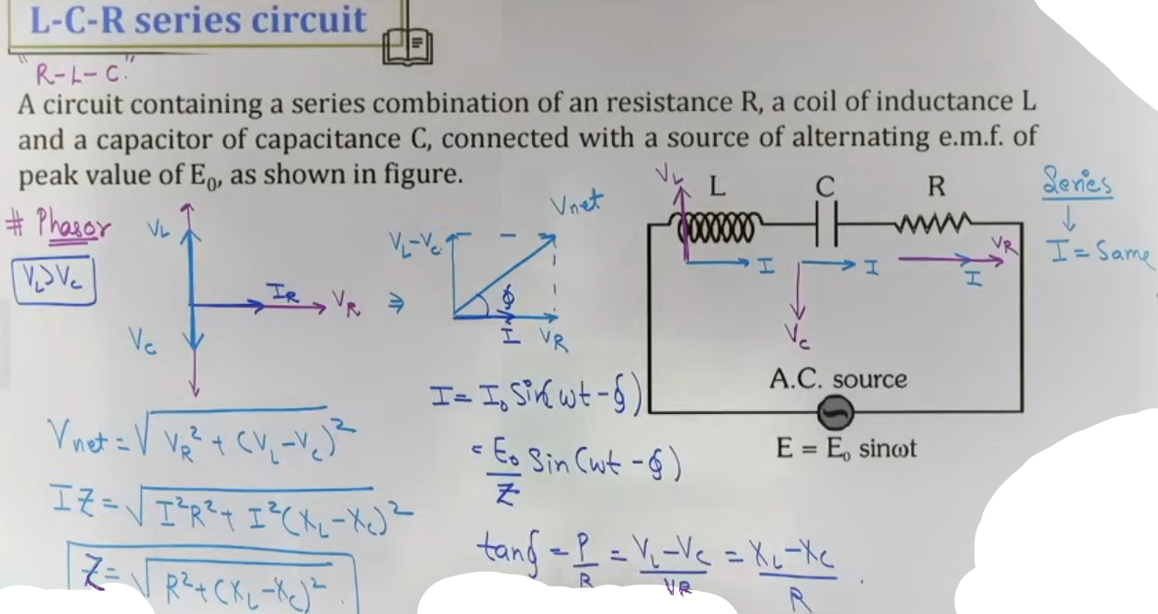
INTUITION AND CONCEPTUAL UNDERSTANDING

THE VECTOR SUM MENTAL MODEL
The teacher explains that even though KVL still holds (the sum of voltages in a loop is zero), you cannot simply add the numbers (e.g., 10V + 10V is not 20V). Because the peaks happen at different times, we use phasors to find the "resultant" voltage, similar to finding the resultant of two perpendicular forces in mechanics.

THE TUG OF WAR (RLC)
In an RLC circuit, think of the Inductor and Capacitor as players in a tug of war. They are pulling in exactly opposite directions. The circuit "feels" only the difference between their strengths. If Xₗ is stronger, the circuit is inductive; if X꜀ is stronger, it is capacitive.

FORMULA SHEET
+--------------+----------------------+------------------+--------------------+
| CIRCUIT TYPE | NET VOLTAGE (V_net) | IMPEDANCE (Z) | PHASE ANGLE (tanϕ) |
+--------------+----------------------+------------------+--------------------+
| Series RL | √(Vᵣ² + Vₗ²) | √(R² + Xₗ²) | Xₗ / R |
| Series RC | √(Vᵣ² + V꜀²) | √(R² + X꜀²) | X꜀ / R |
| Series RLC | √(Vᵣ² + (Vₗ-V꜀)²) | √(R² + (Xₗ-X꜀)²) | (Xₗ-X꜀) / R |
+--------------+----------------------+------------------+--------------------+

Current:
I₀ = V₀ / Z.
Iᵣₘₛ = Vᵣₘₛ / Z.

CONCEPT CONNECTIONS
VARIATION WITH FREQUENCY
- RL Circuit: As frequency (f) increases, Xₗ increases. Therefore, the total impedance Z increases.
- RC Circuit: As frequency (f) increases, X꜀ decreases. At very high frequencies, the capacitor acts like a short circuit, and Z approaches R.
- RLC Circuit: Z is high at very low and very high frequencies. It reaches a minimum value (Z = R) at the resonant frequency.

LINK TO MECHANICS
The series RLC circuit is mathematically analogous to a damped mass-spring system.
- L is analogous to Mass (Inertia).
- R is analogous to Damping Constant (Friction).
- 1/C is analogous to Spring Constant (K).
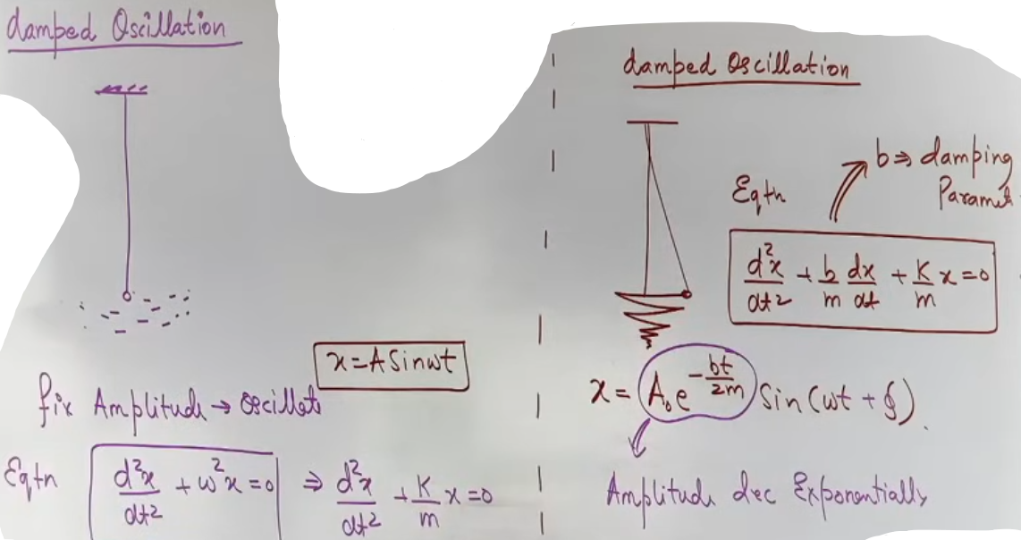
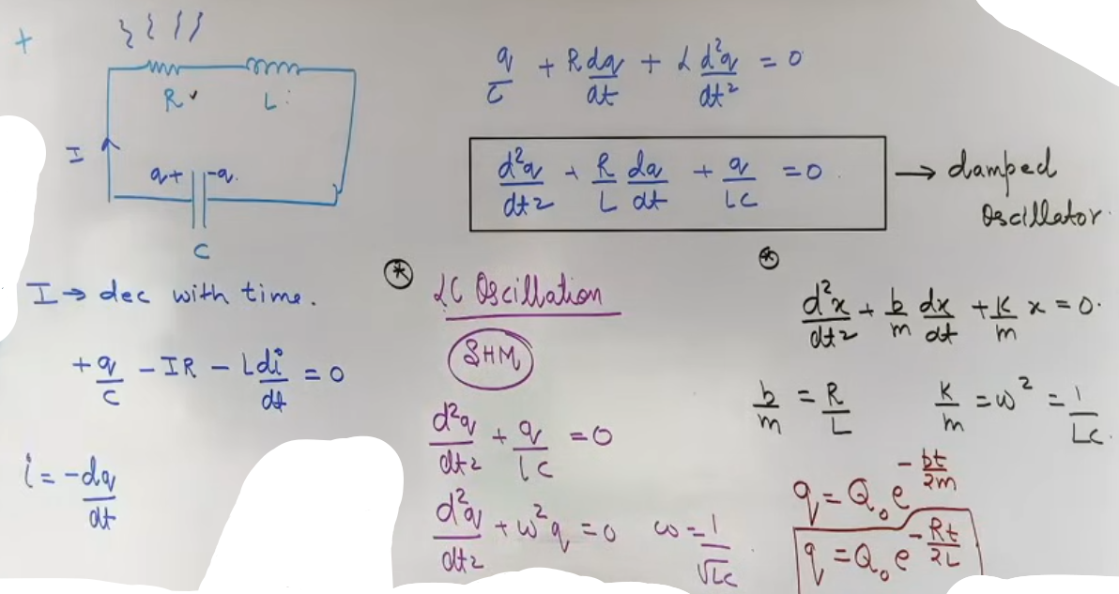
# LC oscillation undamped SHM

EXAMPLES AND APPLICATIONS

IMPEDANCE TRIANGLE
- The impedance triangle is a right-angled triangle where:
Base = Resistance (R).
Perpendicular = Net Reactance (Xₗ - X꜀).
Hypotenuse = Impedance (Z).
- The angle between R and Z is the phase angle (ϕ).

EXAMPLE: RL CIRCUIT ON RAILS
If a circuit has R = 30 ohms and Xₗ = 40 ohms.
Z = √(30² + 40²) = 50 ohms.
tan ϕ = 40/30 = 4/3. Thus, ϕ = 53 degrees. Voltage leads current.
JEE ADVANCED INSIGHTS

VOLTAGE MAGNIFICATION TRAP
In a series RLC circuit, it is possible for the voltage across the inductor (Vₗ) or capacitor (V꜀) to be much greater than the applied supply voltage (V_net). This happens near resonance when Xₗ and X꜀ are very high but cancel each other out.

PHASOR ADDITION IN PARALLEL
While this chapter focuses on Series, the teacher notes that in Parallel circuits, we keep Voltage (V) constant and add Currents (I) as vectors using KCL.

HIGH-YIELD REVISION SHEET

MUST REMEMBER
Z = √(R² + (Xₗ - X꜀)²).
V_net = √(Vᵣ² + (Vₗ - V꜀)²).
tan ϕ = (Xₗ - X꜀) / R.
Power Factor (cos ϕ) = R / Z.

IMPEDANCE VS FREQUENCY (f) TRENDS
_______________________________________________________________
CIRCUIT | AS f INCREASES | Z BEHAVIOR
Pure R | No change | Constant
Pure L | Z increases linearly | Z = 2 * pi * f * L
Pure C | Z decreases hyperbolically | Z = 1 / (2 * pi * f * C)
RLC | Decreases then Increases | Minimum at Resonance

LAST-MINUTE REVISION POINTS
- In a series circuit, current is the reference phasor.
- If tan ϕ is positive, the circuit is Inductive (V leads I). If negative, it is Capacitive (I leads V).
- Impedance (Z) is always measured in Ohms (Ω).
- In Series RLC, when Xₗ = X꜀, the circuit is purely resistive and Z is minimum.

--------------------------------------------------------------------------------

RESONANCE CONDITION
- Resonance is a special state in a series RLC circuit where the inductive reactance (Xₗ) and capacitive reactance (X꜀) become equal.
- Since the voltages across the inductor (Vₗ) and capacitor (V꜀) are 180 degrees out of phase, they completely cancel each other out at this frequency.
- Key mathematical conditions for resonance:
- Xₗ = X꜀.
- Vₗ = V꜀.
- The net reactance (Xₗ - X꜀) is zero.
- The circuit becomes purely resistive (Phase angle ϕ = 0).
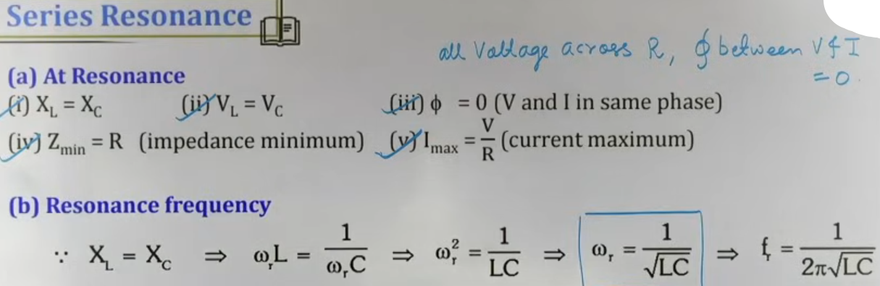

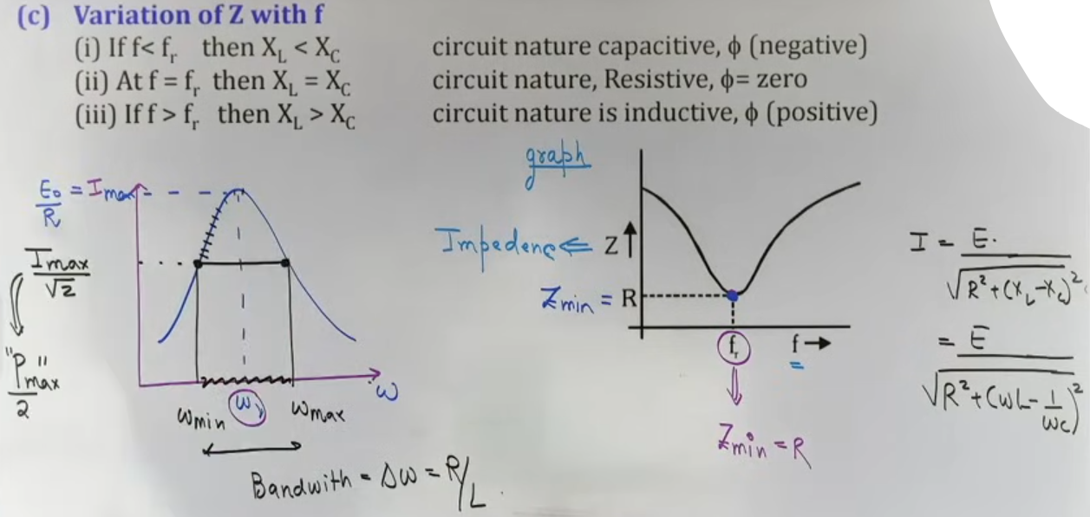
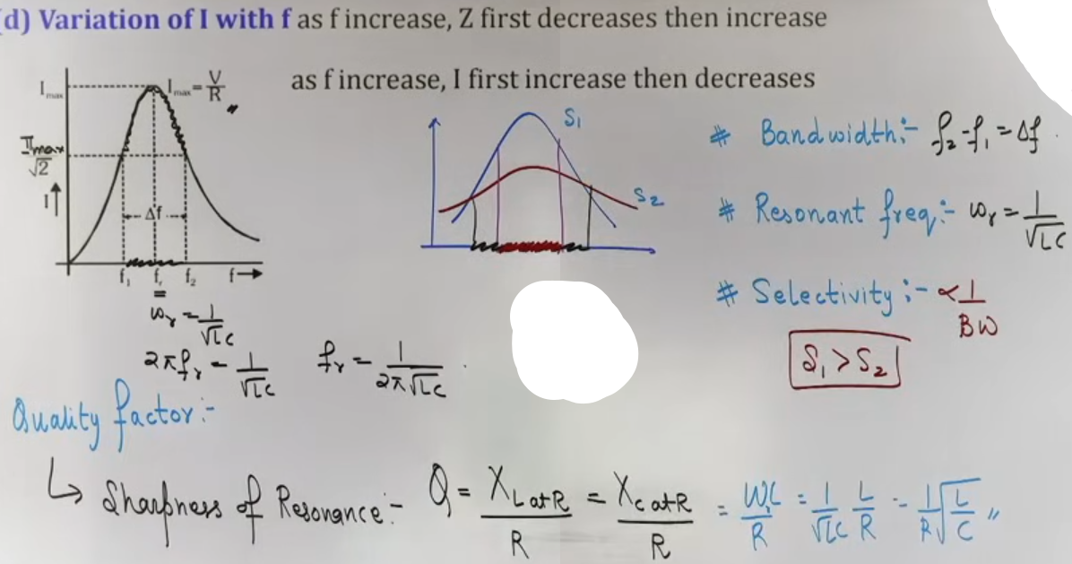

IMPEDANCE AND CURRENT AT RESONANCE
- At resonance, the impedance (Z) reaches its minimum possible value, which is equal to the resistance (R).
- Because impedance is minimum, the current (I) reaches its maximum peak value (Iₘₐₓ = V / R).
- The total voltage applied to the circuit appears entirely across the resistor (V_net = Vᵣ).

RESONANCE FREQUENCY (fᵣ)
- The specific frequency at which resonance occurs depends solely on the values of L and C.
- Angular Resonance Frequency: ωᵣ = 1/√(LC).
- Resonance Frequency in Hertz: fᵣ = 1/(2pi * √(LC)).

INTUITION AND CONCEPTUAL UNDERSTANDING

THE ENERGY SWING ANALOGY
Resonance is like a perfectly timed push on a swing. In an RLC circuit, the inductor and capacitor play a "game of catch" with energy. At resonance, they exchange energy so perfectly that the source only needs to overcome the friction (resistance) to keep the "swing" going at maximum amplitude.

RADIO TUNING ANALOGY
When you set your radio to 95.0 MHz, you are adjusting the internal capacitance or inductance of the receiver circuit so that its natural resonance frequency matches the 95.0 MHz frequency transmitted by the station. When they match, the current in your radio circuit is maximized for that specific signal, allowing you to hear it clearly.

FORMULA SHEET

+-------------------------------+--------------------------+-----------------+
| QUANTITY | FORMULA | NOTES |
+-------------------------------+--------------------------+-----------------+
| Resonance Frequency (Angular) | ωᵣ = 1/√(LC) | rad/s |
| Resonance Frequency (Linear) | fᵣ = 1/(2pi * √(LC)) | Hz |
| Quality Factor (Q) | Q = ωᵣL/R = (1/R)*√(L/C) | Dimensionless |
| Bandwidth (Delta ω) | Δω = ωᵣ/Q = R/L | rad/s |
| Current at Resonance | Iₘₐₓ = Vᵣₘₛ/R | Maximum current |
| Power at Resonance | Pₘₐₓ = (Iᵣₘₛ)² * R | Maximum power |
+-------------------------------+--------------------------+-----------------+

CONCEPT CONNECTIONS

LINK TO SHM AND MECHANICS
A series RLC circuit is mathematically identical to a damped simple harmonic oscillator.
- Inductance (L) corresponds to Mass (m) or Inertia.
- Resistance (R) corresponds to the Damping coefficient (b).
- 1/Capacitance (1/C) corresponds to the Spring constant (k).

LINK TO ENERGY
At resonance, the average energy stored in the magnetic field of the inductor equals the average energy stored in the electric field of the capacitor.

PROBLEM-SOLVING FRAMEWORK

QUESTION TYPE | IDENTIFICATION CLUE | APPROACH / STRATEGY
Find Resonance F_req | Given L and C | Use fᵣ = 1 / (2pi * √(LC)).
Condition for Resonance | "Current and Voltage in phase" | Set Xₗ = X꜀ or ωL = 1/ωC.
Calculate Q Factor | L, C, R are provided | Use Q = (1/R) * √(L/C).
Half-Power Points | "Power becomes half of max" | Current is Iₘₐₓ / √(2) at these points.

EXAMPLES AND APPLICATIONS

EXAMPLE: FM RADIO RECEIVER
- A radio station broadcasts at ω = 10⁶ rad/s. Your receiver has L = 10 micro-Henry.
- To hear the station, you must tune C such that 1 / √(LC) = 10⁶.
- Result: C = 1 / (ω²L). This adjustment is "Tuning".

JEE ADVANCED INSIGHTS

SELECTIVITY AND BANDWIDTH
- Selectivity is the ability of the circuit to distinguish between the desired frequency and others.
- High Selectivity = High Q = Low Bandwidth = Sharp Peak.
- Low Selectivity = Low Q = High Bandwidth = Flat Peak.
- In practical terms, a high Q circuit allows you to hear 95.0 MHz without interference from 95.1 MHz.

VOLTAGE MAGNIFICATION
- At resonance, the voltage across the inductor (Vₗ) or capacitor (V꜀) is Q times the source voltage (Vₛ).
- Formula: Vₗ = Q * Vₛ.
- This means for a high Q circuit, Vₗ can be much larger than the applied voltage, which is a common "trap" in advanced problems.

HIGH-YIELD REVISION SHEET

MUST REMEMBER:
- Resonance: Xₗ = X꜀, Z = R (min), I = V/R (max).
- ωᵣ = 1 / √(LC).
- Quality Factor Q = (1/R) * √(L/C).
- Bandwidth = ω₂ - ω₁ = R / L.
- Sharpness increases as Resistance (R) decreases.

RESONANCE GRAPH SUMMARY:
- Z vs frequency: Dips to a minimum value 'R' at fᵣ.
- I vs frequency: Rises to a maximum value 'V/R' at fᵣ.
- P vs frequency: Rises to a maximum value at fᵣ.

LAST-MINUTE REVISION POINTS:
- Selectivity is inversely proportional to bandwidth.
- For high sharpness, R should be low.
- The "Nawab" peak in current happens exactly at the resonance frequency.
- Tuning a radio involves changing C to reach the resonance condition.

--------------------------------------------------------------------------------

DEFINITION OF POWER IN AC CIRCUITS
In alternating current circuits, the voltage and current may or may not be in phase with each other. Because of this phase difference, the instantaneous power varies over time. Average Power (Pₐᵥ) represents the actual power consumed by the circuit over a complete cycle.

AVERAGE POWER (Pₐᵥ)
Average power is the product of the RMS voltage, the RMS current, and the power factor. Mathematically, it is expressed as Pₐᵥ = Vᵣₘₛ * Iᵣₘₛ * cos ϕ. Only the component of the current that is in phase with the voltage contributes to the actual power dissipation.

POWER FACTOR (cos ϕ)
The power factor is the ratio of the real power (actual power consumed) to the apparent power (Vᵣₘₛ * Iᵣₘₛ). It is represented by cos ϕ, where ϕ is the phase angle between voltage and current. The value of the power factor is always between 0 and 1.

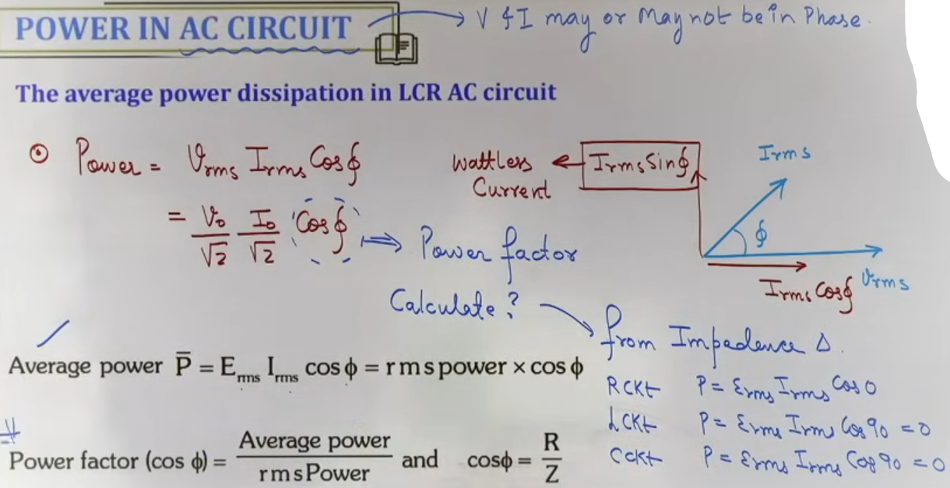

WATTLESS CURRENT
Wattless current is the component of AC current that results in zero net power consumption in the circuit. This typically occurs in purely inductive or purely capacitive circuits where the phase difference is 90 degrees. The magnitude of the wattless current is given by the component Iᵣₘₛ * sin ϕ.

INTUITION AND CONCEPTUAL UNDERSTANDING

THE PROJECTION MENTAL MODEL
The teacher explains that current can be resolved into two components: one along the voltage (Iᵣₘₛ * cos ϕ) and one perpendicular to it (Iᵣₘₛ * sin ϕ). Think of the voltage as the "direction of work". Only the part of the current "pushing" in the same direction as the voltage does actual work, while the perpendicular part (wattless) just sloshes energy back and forth without consuming it.

REAL WORLD ANALOGY
The teacher compares power consumption to mechanical work where force and displacement must have a common component. If a force is perpendicular to the displacement, no work is done; similarly, if current is perpendicular to voltage, no power is consumed.

FORMULA SHEET

QUANTITY | FORMULA | NOTES
-----------------+-----------------------------+--------------------------
Average Power | Pₐᵥ = Vᵣₘₛ * Iᵣₘₛ * cos ϕ | Standard formula
Power Factor | cos ϕ = R / Z | From Impedance Triangle
Wattless Current | I_wattless = Iᵣₘₛ * sin ϕ | Component at 90 deg to V
Apparent Power | P_app = Vᵣₘₛ * Iᵣₘₛ | Max possible power
Peak Power Form | Pₐᵥ = (V₀ * I₀ / 2) * cos ϕ | Using peak values
-----------------+-----------------------------+--------------------------

CONCEPT CONNECTIONS

POWER IN SPECIFIC CIRCUITS
In a purely resistive circuit, the phase angle is 0, making the power factor 1, so Pₐᵥ = Vᵣₘₛ * Iᵣₘₛ. In purely inductive or capacitive circuits, the phase angle is 90 degrees, making the power factor 0, which results in zero power consumption. This is why pure L and C components are highly efficient for controlling current as they do not dissipate heat.
LINK TO IMPEDANCE TRIANGLE
The power factor cos ϕ is calculated as the ratio of Resistance (R) to total Impedance (Z). This links the power properties of the circuit directly to its geometric impedance properties.

# real power = Vᵣₘₛ*Iᵣₘₛ*cos ϕ; apparent power = Vᵣₘₛ*Iᵣₘₛ

EXAMPLES AND APPLICATIONS

EXAMPLE: POWER IN A PURE INDUCTOR
If V = V₀ sin(wt) and I = I₀ sin(wt - 90), the phase difference is 90 degrees. cos(90) is 0, so the average power is 0. This confirms that a pure inductor does not consume power even though current flows through it.

EXAMPLE: DETERMINING POWER FACTOR FROM TRIANGLE
In a circuit where R = 3 and X = 4, the Impedance Z = 5. The power factor cos ϕ = R/Z = 3/5 = 0.6. The average power would be 60 percent of the apparent power.

JEE ADVANCED INSIGHTS

WATTLESS CURRENT SIGNIFICANCE
The wattless current Iᵣₘₛ * sin ϕ is important because even though it consumes no power, it still flows through the wires and contributes to the total current demand from the source. Higher wattless current requires thicker wires to prevent copper losses in the transmission lines.

CHOKE COILS
A choke coil is a high-inductance, low-resistance coil used to limit current in an AC circuit with minimal power loss. Because the phase angle is close to 90 degrees, the power factor is very low, making it much more energy-efficient than using a simple resistor to limit current.

HIGH-YIELD REVISION SHEET

MUST REMEMBER
Average Power Pₐᵥ = Vᵣₘₛ * Iᵣₘₛ * cos ϕ.
Power Factor cos ϕ = R / Z.
Wattless Current I_w = Iᵣₘₛ * sin ϕ.
Real Power = Apparent Power * Power Factor.

LAST-MINUTE REVISION POINTS:
- The power factor is essentially the ratio of actual power used to the capacity of the source being utilized.
- Wattless current is often referred to as "Idle Current".
- In a resonance state (Xₗ = X꜀), the power factor is 1, and power consumption is maximum (P = Vᵣₘₛ²/R).
- Low power factor in industrial circuits is undesirable because it leads to higher transmission losses.
--------------------------------------------------------------------------------

CHOKE COILS
A choke coil is a high-inductance, low-resistance coil used to limit or control alternating current without significant power loss. It is essentially an RL circuit where the inductive reactance X_l is much larger than the resistance R. In an ideal case, the resistance would be zero, meaning the phase difference between voltage and current is 90 degrees, and the power factor cos ϕ is zero. This prevents energy from being wasted as heat.

LCR ANALOGY TO DAMPED SHM
The mathematical behavior of a series LCR circuit is a direct analog to a damped mechanical simple harmonic oscillator (SHM). Both systems follow a second-order differential equation.
- Charge (q) in the circuit behaves like displacement (x) in the mechanical system.
- Current (i = dq/dt) behaves like velocity (v = dx/dt).
- Inductance (L) represents mass (m) or inertia, resisting changes in current/velocity.
- Resistance (R) represents the damping coefficient (b) or friction, dissipating energy.
- Reciprocal of capacitance (1/C) represents the spring constant (k) or stiffness.

TRANSFORMERS
A transformer is an electrical device used to step-up (increase) or step-down (decrease) the magnitude of alternating voltage.
- Operating Principle: It works on the principle of mutual induction between two coils.
- Components: It consists of a primary coil (input), a secondary coil (output), and a common ferromagnetic core (usually laminated soft iron).
- Requirement: It only works with Alternating Current (AC) because it requires a time-varying magnetic flux (dϕ/dt) to induce EMF in the secondary coil. If DC is applied, the flux is constant, and the output is zero.

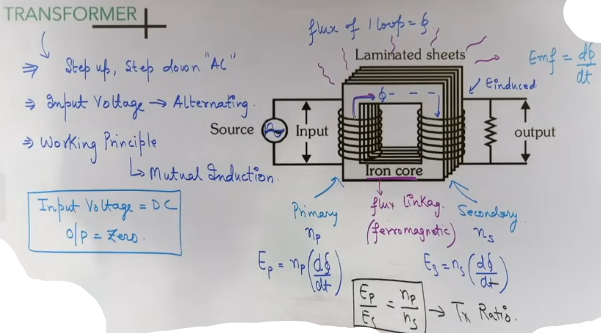
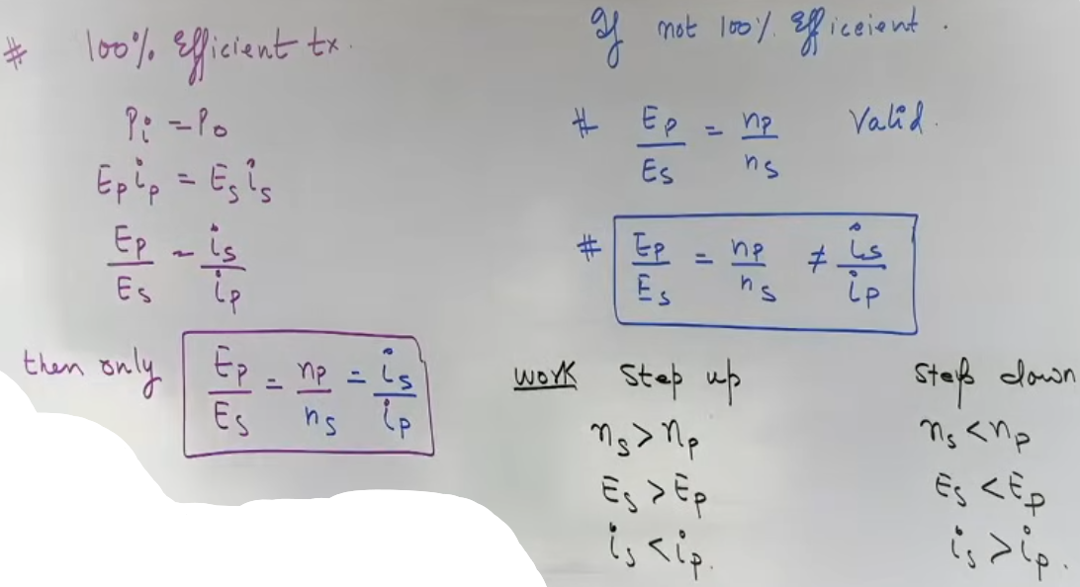
# 100% efficient, Pi = Po, input power = output power

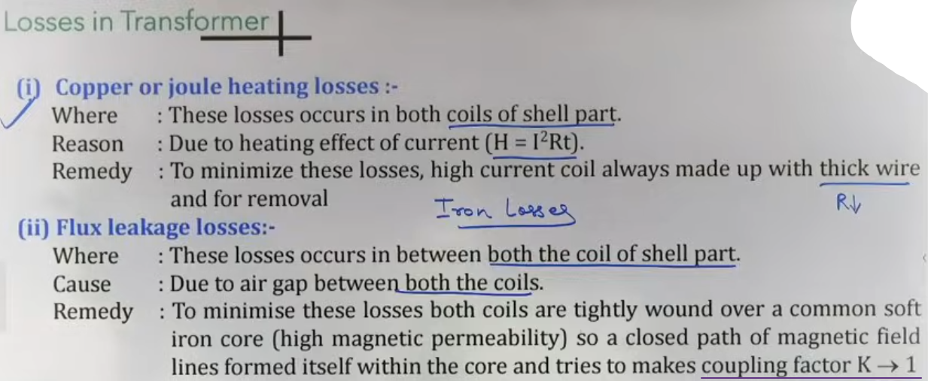
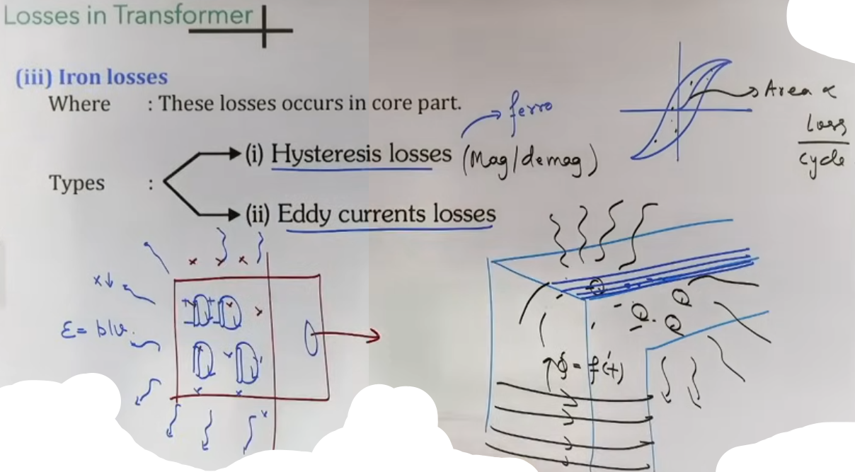

INTUITION AND CONCEPTUAL UNDERSTANDING

THE SMART CONTROLLER (CHOKE COIL)
Think of a choke coil as a smart way to stop current. A normal resistor is like using friction (rubbing your hands) to stop a moving object; it works, but it creates a lot of heat. A choke coil is like using a heavy spring or a massive flywheel; it opposes the motion using "magnetic inertia" and stores the energy rather than burning it off as heat.

THE MAGNETIC BRIDGE (TRANSFORMER)
Visualize the iron core of a transformer as a "magnetic bridge." The primary coil sends out magnetic field lines. The iron core, being ferromagnetic, traps these lines and carries them over to the secondary coil. Without this core, most field lines would escape into the air, and the device would be very inefficient.

CONSERVATION OF ENERGY
A transformer is not a magic machine. If you increase the voltage (Step-up), you must decrease the current. The product of V and I (Power) remains constant in an ideal case. You cannot get more power out than you put in.
FORMULA SHEET

TRANSFORMER TURNS RATIO
Vp / Vs = Np / Ns
- Vp = Primary Voltage
- Vs = Secondary Voltage
- Np = Number of turns in primary
- Ns = Number of turns in secondary

CURRENT RELATION (IDEAL TRANSFORMER ONLY)
Is / Ip = Np / Ns
- Valid only for 100 percent efficiency. Note that current is inversely proportional to the turns ratio.

EFFICIENCY (η)
η = (Output Power / Input Power) * 100
η = (Vs * Is / Vp * Ip) * 100

LCR-SHM MAPPING
- L maps to m (Mass)
- R maps to b (Damping constant)
- 1/C maps to k (Spring constant)
- q maps to x (Displacement)
- i maps to v (Velocity)

CONCEPT CONNECTIONS

- ENERGY DISSIPATION: Resistance (R) is the only component in an LCR circuit that consumes real power, just as friction is the only component in a mechanical system that generates heat.
- EMI LINK: The "Nawab" formula from Electromagnetic Induction (EMF = NABω sin ωt) is what generates the AC signal that the transformer then modifies.
- THERMODYNAMICS: The heating of transformer cores via Eddy currents is a direct conversion of electromagnetic energy into internal thermal energy.

PROBLEM-SOLVING FRAMEWORK

Question Type | Identification Clues | Approach / Strategy
ID Step-up/down | Ns vs Np given | If Ns > Np, it is Step-up. If Ns < Np, it is Step-down.
Calc Output I | η and P_in given | Find Pout = η*P_in. Then use Pout = Vs*Is.
Choke Coil P | L and R given | Calc Z = √(R² + (ωL)²). P = Vrms*Irms*(R/Z).
DC Input | Battery connected | Result is always zero for secondary voltage/current.

EXAMPLES AND APPLICATIONS

POWER GRID TRANSMISSION
Concept: Step-up transformers at power stations.
Key Idea: Voltage is increased to several thousand volts. This reduces the current (I) for the same power. Since heat loss in wires is I²R, reducing I drastically reduces energy wasted as heat during long-distance transmission.

FLUORESCENT TUBE LIGHTS
Concept: Choke coils.
Key Idea: The choke limits the current flowing through the gas-filled tube. If a resistor were used, the light fixture would get extremely hot and waste electricity. The choke stays cool while controlling the current.

JEE ADVANCED INSIGHTS

THE DC INDUCTION TRAP
If a transformer's primary is connected to a battery, you might see a tiny pulse of current in the secondary at the exact moment the switch is closed (due to flux changing from 0 to max). However, for steady DC, the output is strictly zero.

CORE MATERIAL CHOICE
Soft iron is used for the core because it has high permeability and a narrow hysteresis loop. This reduces Hysteresis loss, where energy is lost as the magnetic domains in the core flip back and forth 50 or 60 times per second.

NON-IDEAL CURRENT CALCULATION
In JEE Advanced, if efficiency is 80 percent, you cannot use the Is/Ip = Np/Ns formula. You must use η = (VsIs)/(VpIp) and the turns ratio Vp/Vs = Np/Ns separately.

HIGH-YIELD REVISION SHEET

MUST REMEMBER
- Transformer: Mutual Induction, AC only, Vp/Vs = Np/Ns.
- Choke Coil: High L, Low R, Power Factor approx 0.
- Efficiency η = Pout / Pin.
- LCR Analogy: L=m, R=b, 1/C=k.
- Energy storage: L stores magnetic energy, C stores electric energy.

TRANSFORMER LOSSES SUMMARY TABLE
Loss Type | Cause | How to Reduce
Copper Loss | Resistance of wire (I²R) | Use thick copper wires.
Flux Leakage | Air gaps between coils | Better core design / winding on top of each other.
Hysteresis Loss | Reversing magnetization | Use soft iron core.
Eddy Currents | Induced current in bulk core | Use laminated core (thin sheets).

LAST-MINUTE REVISION POINTS
- Step-up = More turns in secondary = Higher V = Lower I.
- In an ideal transformer, input power = output power.
- The frequency of AC (e.g., 50Hz) remains UNCHANGED by a transformer.
- If a transformer core is not laminated, it will overheat and potentially melt the insulation.

